# Entity Relationship Diagram

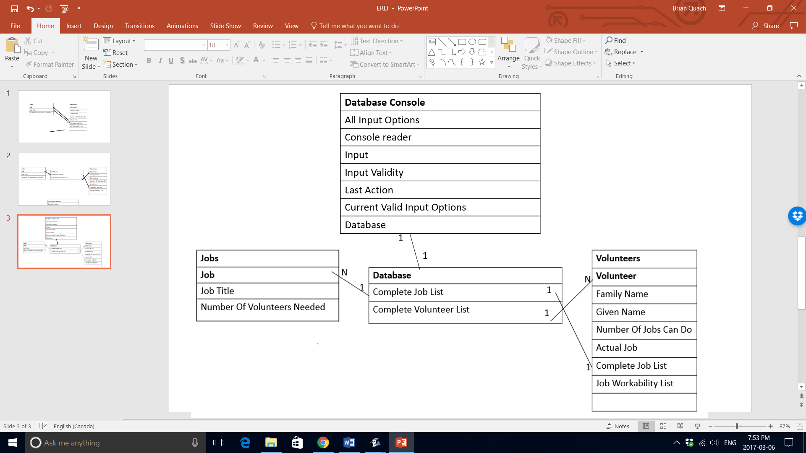

# Objects and their fields and datatypes

Object: Job

|  |  |  |  |
| --- | --- | --- | --- |
| Field Name | Data type | Description | Other Information |
| jobTitle | String | The job title of this job |  |
| numberOfVolunteersNeeded | int | The number of volunteers needed for this job | Is always greater than 0 |

Object: Volunteer

|  |  |  |  |
| --- | --- | --- | --- |
| Field Name | Data type | Description | Other Information |
| actualJob | Job | The actual job of this volunteer |  |
| canDoJob | Boolean[] | The ability of this volunteer to do each job corresponding to the index of the Boolean array | Size of array is equal to number of jobs |
| familyName | String | The family name of this volunteer |  |
| givenName | String | The given name of this volunteer |  |
| job | ArrayList <job> | The complete list of jobs in the database of this volunteer |  |
| numberOfJobsCanDo | int | The number of jobs this volunteer can do |  |

Object: Database

|  |  |  |  |
| --- | --- | --- | --- |
| Field Name | Data type | Description | Other Information |
| job | ArrayList<job> | The complete list of jobs in this database |  |
| jobsHaveBeenAssigned | Boolean | If jobs have been assigned yet |  |
| volunteer | ArrayList<volunteer> | The complete list of volunteers in this database |  |

Object: Database Console

|  |  |  |  |
| --- | --- | --- | --- |
| Field Name | Data type | Description | Other Information |
| OPTION | Int[] | The standard numbers that can be selected to traverse different menus | Are the numbers ranging from 1-8 |
| consoleReader | BufferedReader | The buffered reader of the console |  |
| database1 | Database | The database for this console | Size of array is equal to number of jobs |
| input | String | The console input |  |
| inputIsValid | Boolean | If the input from console is one of the inputs allowed |  |
| lastAction | enum LastAction | The last action done by the database | Possible Last Actions are: ADD_JOB, ADD_VOLUNTEER, ASSIGN_VOLUNTEERS_TO_JOBS, DELETE_JOB, DELETE_VOLUNTEER, INVALID_INPUT, NONE |
| validInputOption | int[] | The scenario-specific numbers that can be selected to do unique actions |  |

# Proposed Queries

|  |  |
| --- | --- |
| Query Name | Description |
| displayGivenJob | Prints out the information of a job, given its job title |
| displayGivenVolunteer | Prints out the information of a given volunteer, given its family and given name. |
| displayLastAction | Prints out the last action done by the database |

# Proposed Forms

|  |  |
| --- | --- |
| Form Name | Description |
| addJob | Given its name and number of volunteers needed, adds job to the end of the job list |
| addVolunteer | Given its name and jobs they are able to do, adds the volunteer to the end of the volunteer list |

# Proposed Reports

|  |  |
| --- | --- |
| Report Name | Description |
| displayActualJobsOfVolunteers | Prints out the volunteers and their actual jobs beside their name |
| displayCurrentJobs | Prints out the titles of the current jobs added and the number of volunteers it needs |
| displayCurrentVolunteers | Prints out the names of the volunteers and the jobs they feel comfortable working in |
| displayJobsAndTheirVolunteers | Prints out the jobs and prints out the volunteers of each job below each job. |
| displayExtraJobs | Prints out the jobs that still require volunteers |
| displayVolunteersWithoutJobs | Prints out volunteers that don’t have jobs |

# Proposed Tests

|  |  |  |
| --- | --- | --- |
| Test Type | Test | Example of success |
| Forms function | Input data in a form and see if it is maintained correctly | Inputting a job with a job title and number of volunteers required will create a new job with that job title and number of volunteers, and add it to the end of the job list |
| Queries Function | Command the console the output a specific object | Input in console the command to print out a specific volunteer of a given family and given name and see if the correct volunteer information is printed |
| Relationships function | Change instance fields in one object to see if it properly affects other objects | When a volunteer is assigned a job in the volunteer class, that specific job needs one less volunteer |
| Reports Function | Command the console to output a report | When the command to print out the list of volunteers without jobs is given, it is done |